Question 1:
[org 0x0100]
jmp start
value: dw '0'
xCoodinate: dw 0
yCoodinate: dw 0
tick_count: dw 0

printAsterisk:
push bp
mov bp, sp
push ax
push bx
push cx
push dx
push es
push di
mov ax, 0xb800
mov es, ax
mov al, 80
mul byte [yCoodinate]
add ax, [xCoodinate]
shl ax, 1
mov di, ax
mov word [es:di], 0x072A
pop di
pop es
pop dx
pop cx
pop bx
pop ax
pop bp
ret

storeValue:
push bp
mov bp, sp
push ax
push bx
push cx
push dx
push es
push di
mov ax, 0xb800
mov es, ax
mov al, 80
mul byte [yCoodinate]
add ax, [xCoodinate]
shl ax, 1
mov di, ax
mov ax, [es:di]
mov [value], ax
pop di
pop es
pop dx
pop cx
pop bx
pop ax
pop bp
ret

moveAsterisk:
mov ax, 0xb800
mov es, ax
mov al, 80
mul byte [yCoodinate]
add ax, [xCoodinate]
shl ax, 1
mov di, ax
mov ax, [value]
mov word [es:di], ax
mov ax, [xCoodinate]
mov bx, [yCoodinate]
cmp ax, 78
je moveDown
cmp bx, 24
je moveLeft
cmp ax, 0
je moveUp

moveRight:
inc word [xCoodinate]
call storeValue
call printAsterisk
jmp endFunc

moveDown:
cmp bx, 24
je moveLeft
inc word [yCoodinate]
call storeValue
call printAsterisk
jmp endFunc

moveLeft:
cmp ax, 0
je moveUp
dec word [xCoodinate]
call storeValue
call printAsterisk
jmp endFunc

moveUp:
cmp bx, 0
je moveRight
dec word [yCoodinate]
call storeValue
call printAsterisk

endFunc:
ret

myIsrForTimer:
push ax
inc word [tick_count]
call moveAsterisk
mov al, 0x20
out 0x20, al
pop ax
iret

start:
mov ax, 0xb800
mov es, ax
mov ax, [es:0]
mov [value], ax
xor ax, ax
mov es, ax
cli
mov word [es:8*4], myIsrForTimer
mov [es:8*4+2], cs
sti
mov ax, 0x4c00
int 21h

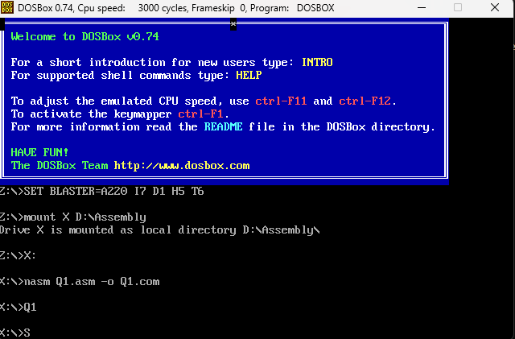

Question 2:
[org 0x0100]
jmp start
saved_char: dw '0'

x_pos: dw 0
y_pos: dw 0
saved_x_pos: dw 0
saved_y_pos: dw 0
is_moving: db 0
scan_code: db 0
clrscr:
push es
push ax
push cx
push di
mov ax, 0xb800
mov es, ax
xor di, di
mov ax, 0x3020
mov cx, 2000
cld
rep stosw
pop di
pop cx
pop ax
pop es
ret
drawAsterisk:
push bp
mov bp, sp
push ax
push bx
push cx

push dx
push es
push di
mov ax, 0xb800
mov es, ax
mov al, 80
mul byte [y_pos]
add ax, [x_pos]
shl ax, 1
mov di, ax
mov word [es:di], 0x302A
pop di
pop es
pop dx
pop cx
pop bx
pop ax
pop bp
ret

saveCharAtPos:
push bp
mov bp, sp
push ax
push bx
push cx
push dx
push es
push di

mov ax, 0xb800
mov es, ax
mov al, 80
mul byte [y_pos]
add ax, [x_pos]
shl ax, 1
mov di, ax
mov ax, [es:di]
mov [saved_char], ax
pop di
pop es
pop dx
pop cx
pop bx
pop ax
pop bp
ret

moveAsterisk:
mov ax, 0xb800
mov es, ax
mov al, 80
mul byte [y_pos]
add ax, [x_pos]
shl ax, 1
mov di, ax
mov ax, [saved_char]
mov word [es:di], ax
mov ax, [x_pos]

mov bx, [y_pos]
cmp ax, 78
je moveDown
cmp bx, 24
je moveLeft
cmp ax, 0
je moveUp

moveRight:
inc word [x_pos]
call saveCharAtPos
call drawAsterisk
jmp movementEnd

moveDown:
cmp bx, 24
je moveLeft
inc word [y_pos]
call saveCharAtPos
call drawAsterisk
jmp movementEnd

moveLeft:
cmp ax, 0
je moveUp
dec word [x_pos]
call saveCharAtPos
call drawAsterisk
jmp movementEnd

moveUp:
cmp bx, 0
je moveRight
dec word [y_pos]
call saveCharAtPos
call drawAsterisk

movementEnd:
ret

keyboardISR:
push ax
push bx
push cx
push dx
in al, 0x60
mov [scan_code], al
cmp al, 0x2A
je startMovement
cmp al, 0x36
je stopMovement

continueISR:
in al, 0x61
mov ah, al
or al, 80h
out 0x61, al
mov al, ah

out 0x61, al
mov al, 0x20
out 0x20, al
pop dx
pop cx
pop bx
pop ax
iret

startMovement:
mov byte [is_moving], 1
mov ax, [saved_x_pos]
mov [x_pos], ax
mov bx, [saved_y_pos]
mov [y_pos], bx
jmp continueISR

stopMovement:
push di
mov byte [is_moving], 0
mov ax, [x_pos]
mov [saved_x_pos], ax
xor ax, ax
mov bx, [y_pos]
mov [saved_y_pos], bx
pop di
jmp continueISR

resumeMovement:
mov byte [is_moving], 1
mov ax, [x_pos]
mov bx, [y_pos]
call saveCharAtPos
call drawAsterisk
jmp continueISR

timerISR:
push ax
cmp byte [is_moving], 1
jne skipMovement
call moveAsterisk
skipMovement:
mov al, 0x20
out 0x20, al
pop ax
iret

start:
; call clrscr
mov ax, 0xb800
mov es, ax
mov ax, [es:0]
mov [saved_char], ax
xor ax, ax
mov es, ax
cli
mov ax, 0

mov es, ax
mov word [es:9*4], keyboardISR
mov word [es:9*4+2], cs
mov word [es:8*4], timerISR
mov word [es:8*4+2], cs
sti
mov ax, 0x4c00
int 21h

